**TASK NO 01- Which of the following values can be assigned to variables of type float, double and decimal.**

**SOLUTION:**

THE DATA TYPES OF GIVEN VALUES ARE GIVEN BELOW.

**(1) 5 FLOAT, DOUBLE, DECIMAL.**

**(2) -5.01 FLOAT, DOUBLE, DECIMAL.**

**(3) 34.567839023 DOUBLE, DECIMAL.**

**(4) 12.345 FLOAT, DOUBLE, DECIMAL.**

**(5) 8923.1234857 DOUBLE, DECIMAL.**

**(6) 3456.091124875956542151256683467 NOT POSSIBLE.**

**TASK NO 02- Create a simple calculator which will perform all arithmetical, Bit wise operation and logical operation on two number.**

**------------------ARITHMETIC OPERATORS---------------**

**SOLUTION:**

double A, B;

Console.Write("ENTER NUMBER A: ");

A = Convert.ToDouble(Console.ReadLine());

Console.Write("ENTER NUMBER B: ");

B = Convert.ToDouble(Console.ReadLine());

Console.WriteLine("\n-------ARITHMETIC ------");

Console.WriteLine("a + b = "+ (A+B));

Console.WriteLine("a - b = "+ (A+B));

Console.WriteLine("a * b = "+ (A*B));

Console.WriteLine("a / b = "+ (A/B));

Console.WriteLine("a % b = "+ (A%B));

Console.WriteLine("++ b = "+ (++B));

Console.WriteLine("b-- = "+ (B--));

**OUTPUT:**

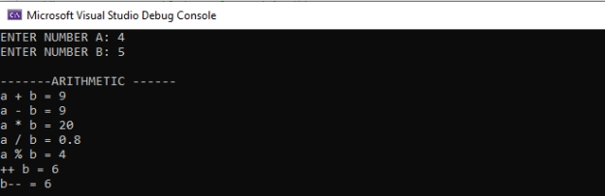

**------------------LOGICAL OPERATORS---------------**

**SOLUTION:**

{

bool a, b;

Console.WriteLine("*******logical operators********");

Console.Write("\n select true or false number: ");

a = Convert.ToBoolean(Console.ReadLine());

Console.Write("select true or false number: ");

b = Convert.ToBoolean(Console.ReadLine());

Console.WriteLine("a && b = {0}", a && b);

Console.WriteLine("a || b = {0}",a || b);

Console.WriteLine(" !b = {0}", !b );

Console.WriteLine(" !a = {0}", !a );

}

**OUTPUT:**

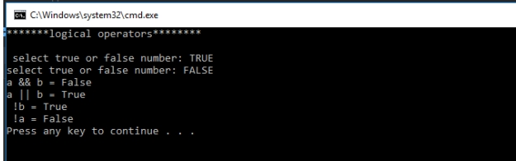

**------------------BITWISE OPERATORS---------------**

**SOLUTION:**

int num1, num2,x,y;

Console.WriteLine("****** BITWISE OPERATORS *******");

Console.Write("enter your first number: ");

num1 = Convert.ToInt32(Console.ReadLine());

Console.Write("enter your second number: ");

num2 = Convert.ToInt32(Console.ReadLine());

x = num1;

y = num2;

Console.WriteLine("x & y = {0}", x & y);

Console.WriteLine("x | y = {0}", x | y);

Console.WriteLine("x ^ y = {0}", x ^ y);

Console.WriteLine("x << y = {0}", x << y);

Console.WriteLine("x >> y = {0}", x >> y);

**OUTPUT:**

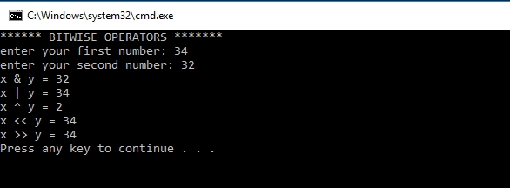

**TASK NO 03- Create a simple program to calculate Hypotenuse using Pythagoras theorem c^2 =(a^2 + b^2).**

**SOLUTION:**

{

double a, b,c;

Console.Write("enter value of a: ");

a =Convert.ToDouble(Console.ReadLine());

Console.Write("enter value of b: ");

b = Convert.ToDouble(Console.ReadLine());

c = (a * a)+(b * b);

c = Math.Pow(c,0.5);

Console.WriteLine("my answer is= "+ c);

}

**OUTPUT:**

